**CREATE AND CONFIGURE IBM**

**SERVICES IOT WATSON PLATFORM**

**SMARTFARMER - IOT ENABLED SMART FARMING**

**APPLICATION**

Team ID: PNT2022TMID19528

Team Members:

Subahan.K[LEAD]

Hassain.K.M

Sai kumar. G

Nikhil.K

**Step1**: Log in your registered id

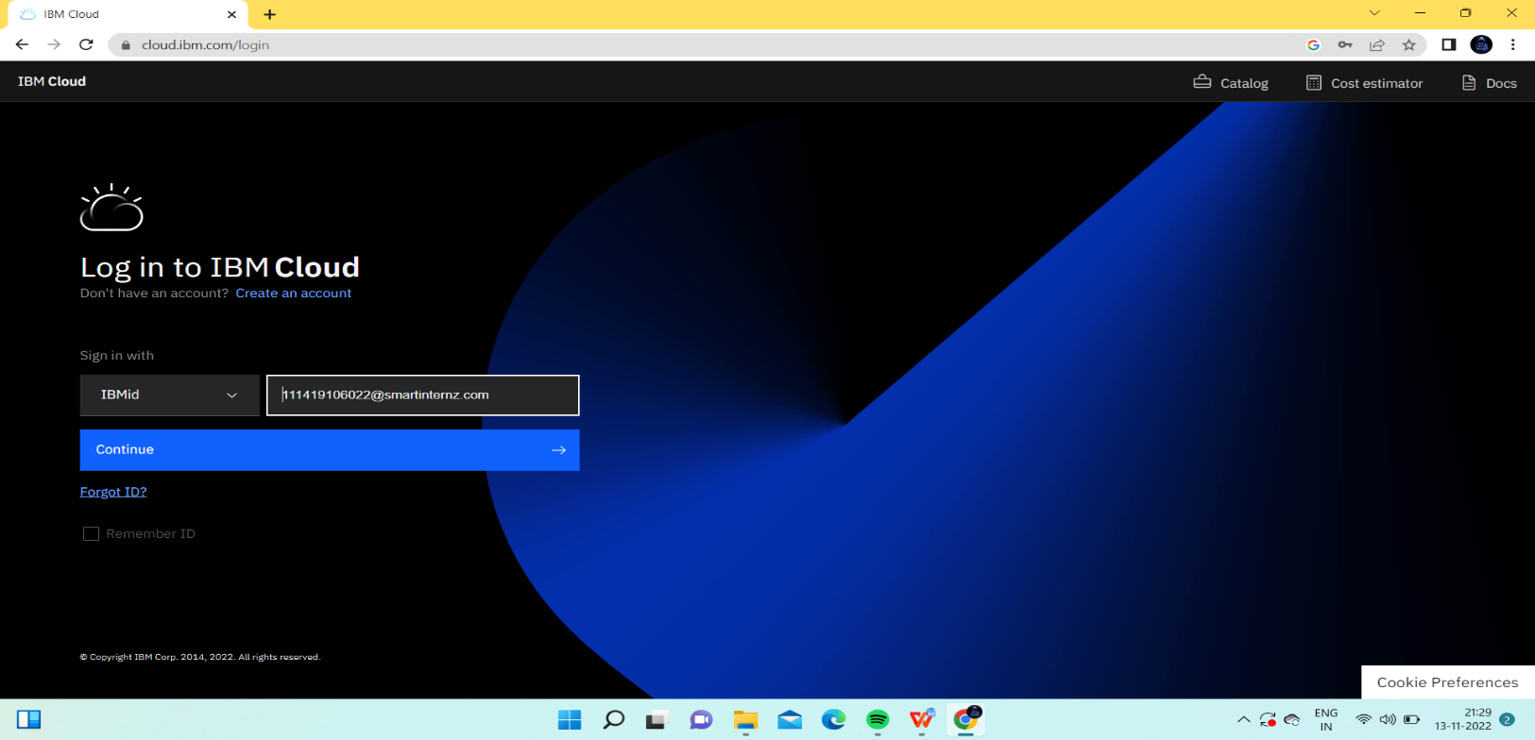

**Step 2**: click catalog where you find the services and internet of thing you can select and make location as London

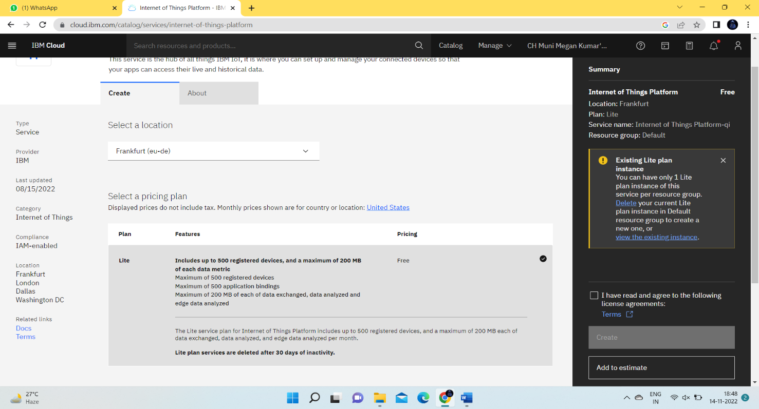

**Step 3**: click create and the launch tab get open, then click launch

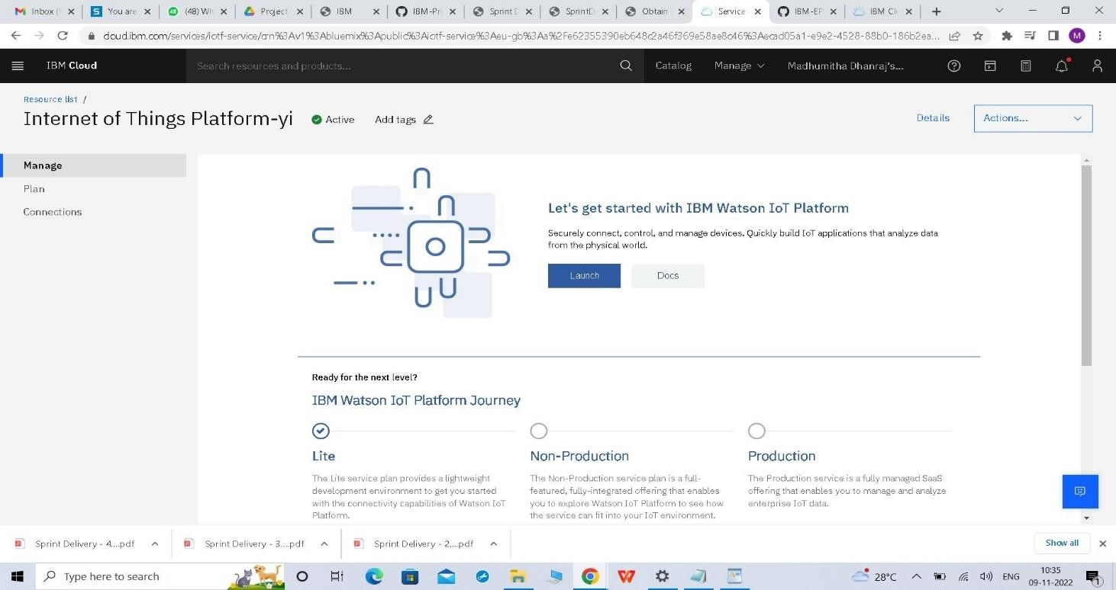

**Step 4**: It redirect you to IBM WATSON platform where you need to click sign in

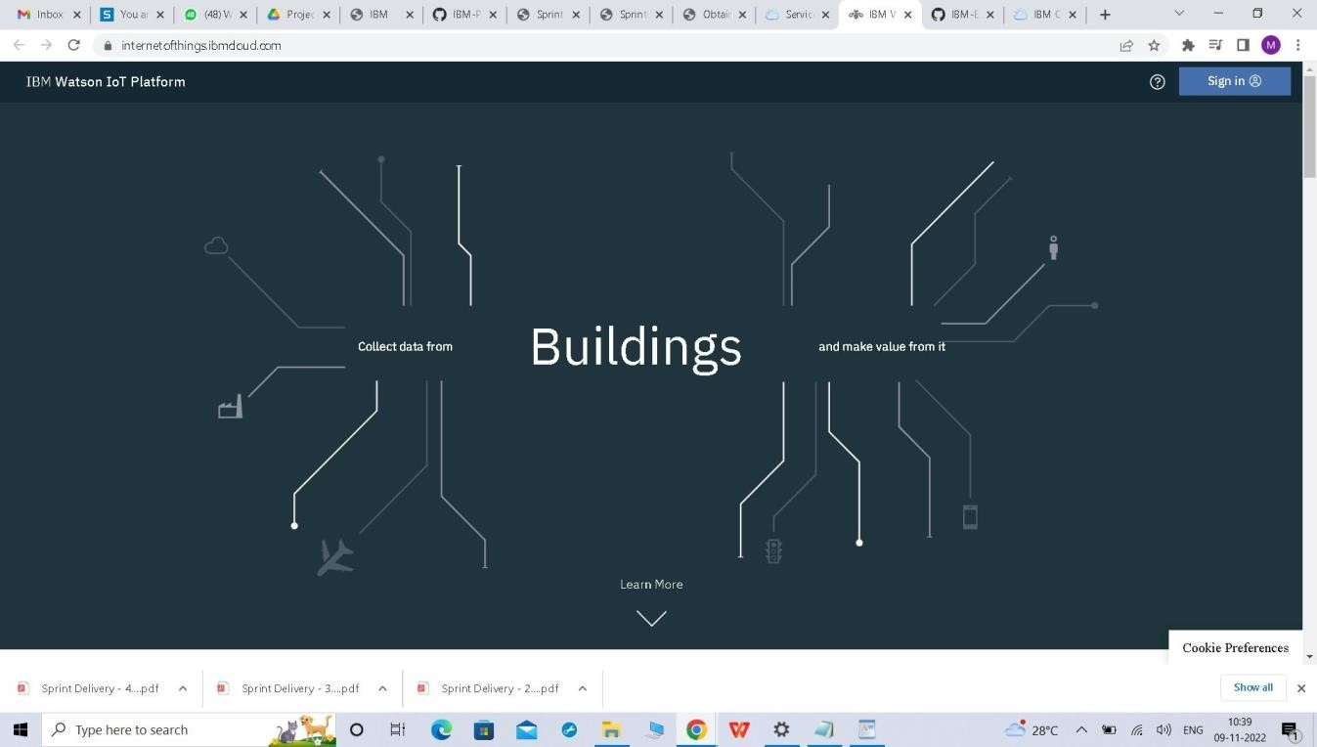

**Step 5**:log in with IBM ID

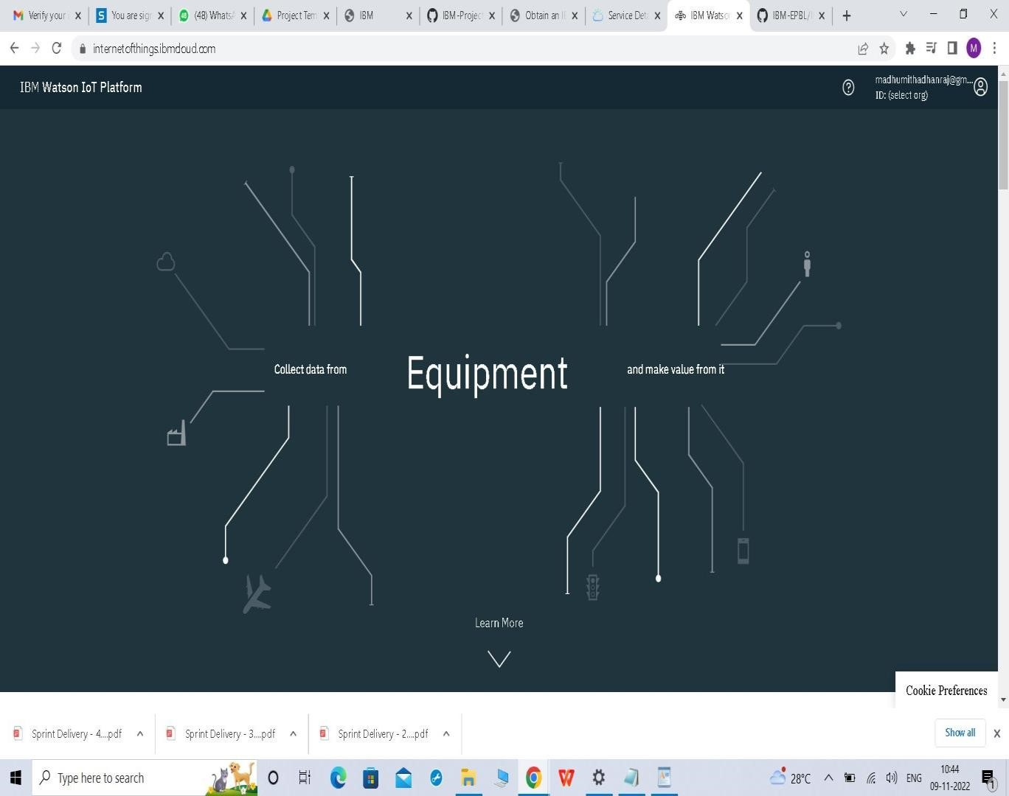

**Step 6**: where you find this tab which is used to add device , app, member ,usage , security can be worked

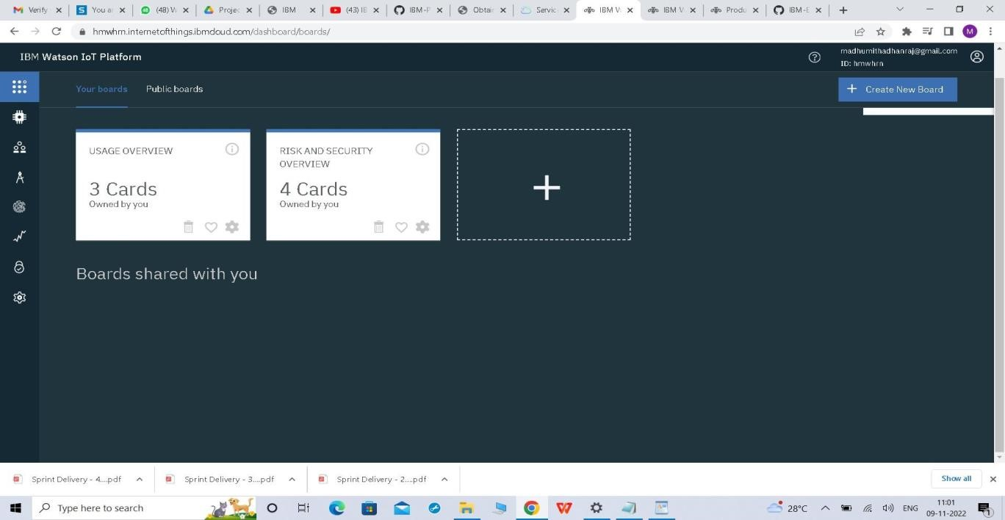

**Step 7**: check boards for risk and security overview card , it uses for graphical representation boards

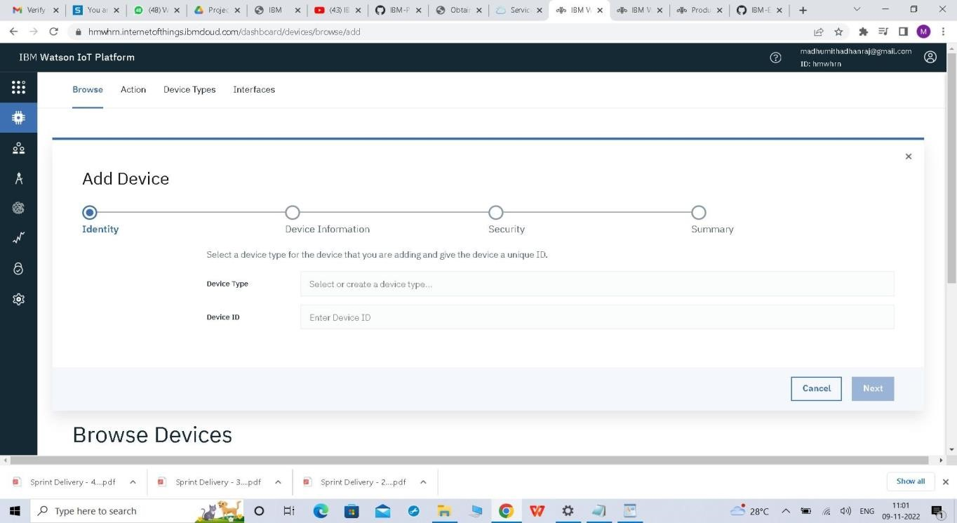

**Step 8**: after clicking create a new device / add device you can choose an device type and device id and complete the following information to create a device

